THE SEAGULL RESEARCH – RUSSIA

Women in 19th Century Russia:

Despite many similarities, women’s status in Russia differed from that in Europe and America because of its unique political situation. Serfs were freed only in 1861, and as Engel notes, Russia’s transition from feudalism to capitalism, which took centuries in Europe, happened in just 25 years, accelerated by rail and steamship transport.

‘The market provided only a limited range of poorly-paid and exploitative choices’. Women could work in factories or as servants, physicians, midwives, telegraph operators, and teachers. Some gained access to fashion, books, entertainment, and education. However, married women still owed their husbands obedience and needed permission to work, study, or live more than fifteen miles away.

In general, cases of rape and wife-beating, even where the woman died, were not treated as serious by the courts. Women resisted these restrictions: around 30–40,000 petitioned the tsar for separation from their husbands. However, petitions were often rejected if women were suspected of “immoral behaviour,” the courts didn’t side with women in most cases.

The Government:

Nicholas I (ruled 1825–1855)
- His rule slowed down progress and angered educated people because of strict censorship.
- Russia’s reputation in Europe fell after losing the Crimean War (1853–1856).
- Nicholas I died in 1855, leaving his son a country in serious trouble.

Alexander II (ruled 1855–1881)
- Took over a country with military, political, and economic problems.
- Tried to modernize Russia through big reforms:
  - Freed the serfs (1861) – his most important reform.
  - Local government reforms:
    - Zemstvos (1864) – local councils in villages.
    - City dumas (1870) – local councils in towns.
  - Court reform (1864) – made the legal system fairer.
  - Military reform (1874) – created universal conscription, so men from all classes had to serve.
- Many educated Russians (intelligentsia) thought his reforms were not enough, which led to radical groups like the Narodniki in the 1860s–70s.

Alexander III (ruled 1881–1894)
- After his father’s death, he reversed many reforms and brought back strict, conservative rule.
- Supported Panslavism and Orthodoxy — the idea that Russia should protect its religion and Slavic culture.
- His advisor Konstantin Pobedonostsev promoted very traditional, anti-liberal views, unlike the more open-minded Loris-Melikov.
- Even with more control, the educated class stayed politically active and often opposed his policies.
- Focused on economic growth, especially the Trans-Siberian Railway, to connect and strengthen the empire.
Russia before 1905: Backward and Autocratic
• Compared to Western Europe, Russia was politically, economically, and socially behind.
• The economy was mainly agricultural, with most people living as poor, illiterate peasants.
• Many peasants were still serfs, working under the control of wealthy landowners.

The Tsarist System – “Pillars of Autocracy”

1. Autocratic Government
• The Tsar had absolute power, only he could govern.
• He ruled by divine right, believing his authority came from God.

2. Nobility
• Made up about 10% of the population and owned most of the land.
• Depended on the Tsar for power and wealth, so they were very loyal.
• Controlled the army and civil service, helping the Tsar run the empire.

3. The Law
• The legal system protected the Tsar, not the people.
• No parliament or elections. Citizens couldn’t challenge his power.
• Opponents were punished harshly, often exiled to Siberia.

4. The Okhrana (Secret Police)
• Spied on and arrested anyone seen as a threat to the Tsar.
• Used torture and murder to destroy opposition.
• Operated in secret, often infiltrating revolutionary groups.

5. The Orthodox Church
• Taught that the Tsar was chosen by God and should not be challenged.
• The Church spread loyalty among peasants through religious teaching.
• Many priests were seen as corrupt, which weakened respect for the Church.

- Weaknesses of the Tsarist System
• The Empire was huge, making it hard to govern effectively.
• Corruption and incompetence were common among officials.
• Poor roads and railways made it difficult for revolutionary ideas to spread.
• Most peasants were illiterate and isolated, limiting organised opposition.

Growing Opposition
• Liberals wanted a constitutional government and more rights for citizens.
• Radicals used violence and assassination to fight autocracy.
• Marxist ideas spread in the late 1800s, inspiring new revolutionary groups:
• Social Revolutionaries (SRs): wanted to give power to peasants; carried out about 2,000 assassinations.
• Social Democrats (SDs): based on Marxism; focused on workers.
• Split in 1903 into:
• Mensheviks (Martov): wanted a slow, natural revolution by workers.
• Bolsheviks (Lenin): wanted an immediate revolution led by a small elite group.

Industrial Growth:

• In the 1800s, Russia was mainly agricultural, with little heavy industry compared to Western Europe.
• Defeat in the Crimean War (1853–1856) led to reforms like the emancipation of the serfs (1861) to create a free labour force for industry.
• Sergei Witte introduced major economic reforms, attracting foreign investment and expanding railways and factories.
• Industry grew quickly in the 1890s, drawing many peasants into cities to work in factories.
• Housing did not keep up with growth, and workers lived in overcrowded, dirty dormitories with poor food and freezing conditions.
• Factory life was harsh, with long hours, low pay, and dangerous work.
• Witte’s reforms increased production but created an exploited industrial class open to revolutionary ideas.

Imperial Expansion in Central Asia:

In the 1800s, Russia expanded into the Kazakh steppe and the Central Asian khanates of Kokand, Bukhara, and Khiva to secure its southern borders and counter British influence. Local rulers were often kept as figureheads, while railroads and new towns strengthened Russian control and trade. Russian settlers and the exploitation of land and resources displaced locals, disrupted traditional life, and caused resentment and uprisings. Some modernisation projects, including education, irrigation, and European-style towns, created a small Westernised elite and increased Russian influence.

Art in Russia:
The most famous Russian writers of the 1800s include:
- Leo Tolstoy – War and Peace (1869), about aristocratic families during the Napoleonic Wars; Anna Karenina (1875), exploring love, betrayal, and society.
- Fyodor Dostoevsky – Crime and Punishment (1866), a psychological thriller; The Brothers Karamazov (1880), on faith and morality; Notes from Underground (1864), exploring the darker human psyche.
- Alexander Pushkin – Eugene Onegin (1831), a novel in verse examining love and society.
- Nikolai Gogol – Dead Souls (1842), satirizing Russian society; The Nose (1836), a surreal satire.
- Ivan Turgenev – Fathers and Sons (1862), about generational conflict and emerging nihilist ideas.

Paintings:

Grigory Myasoyedov. The Reading of the Manifesto of February 19, 1861 (1873)
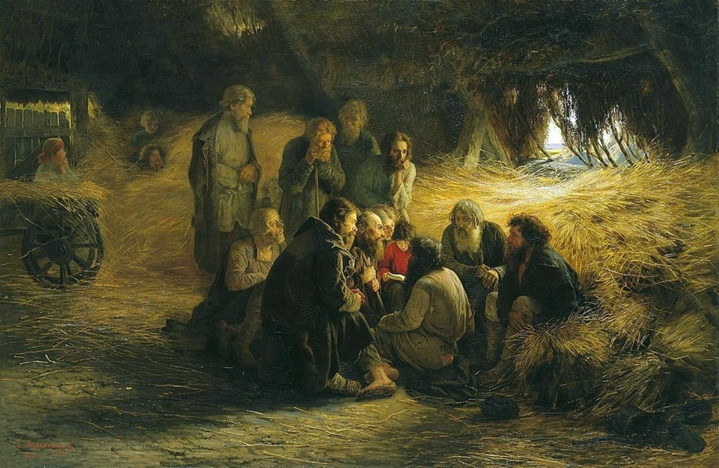

Ilya Repin. Ivan the Terrible and his Son Ivan, November 16, 1581 (1883-85)
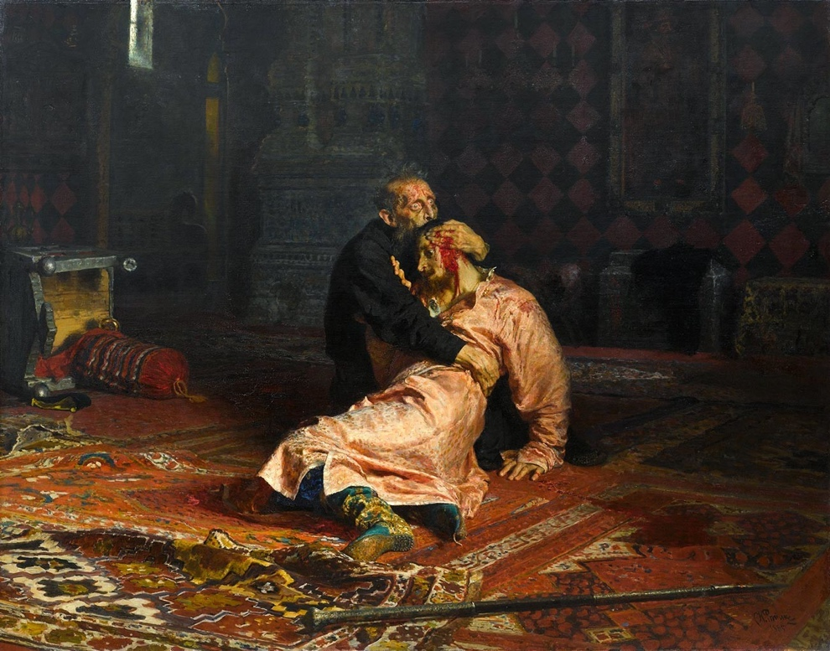

Ilya Repin, They Did Not Expect Him, 1884-88

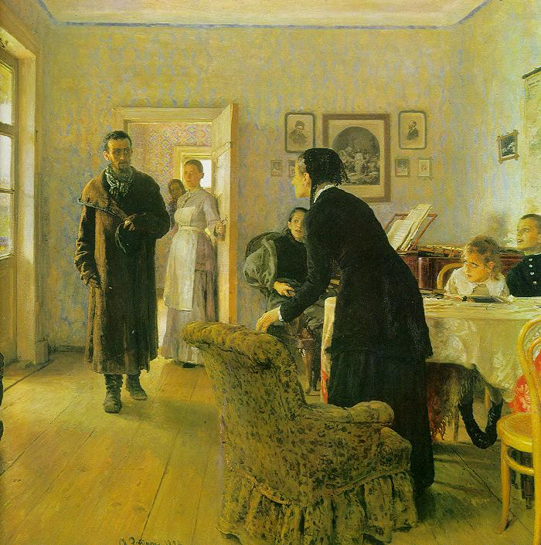
A very helpful article on “The Wanderers: An early Revolution in Russian Art”: https://museumstudiesabroad.org/the-wanderers/

Music:

“The Five,” also known as the “Mighty Five” or “New Russian School,” was a group of five Russian composers—Mily Balakirev, Alexander Borodin, César Cui, Modest Mussorgsky, and Nikolai Rimsky-Korsakov—who aimed to create a distinct Russian classical music style. They collaborated in Saint Petersburg from 1856 to 1870.

Songs by the Mighty Five:
- Rimsky-Korsakov composed Flight of the Bumblebee has since been used in multiple films such as Shine, and Kill Bill: Vol 1 due to its successful interpretation of a bee’s erratic flying.
- Borodin is the mind behind the opera Prince Igor which has gained notoriety for the Polovtsian Dances and is a largely successful opera within Russia and has been performed globally.
- Mussorgsky composed Pictures at an Exhibition, which consists of ten different piano pieces reflecting artwork by his friend, the artist Victor Hartmann and are all linked together, symbolising walking through an exhibition.

Russian Films in the Early 20th Century:
- Battleship Potemkin and Strike:
These are the work of director Sergei Eisenstein, released in 1925. These silent movies are uses of what is deemed a revolutionary silent film technique, the montage. Battleship Potemkin uses the story of the 1905 mutiny of the real-life ship, Potemkin to further symbolise the revolutionary movement using powerful scenes such as the massacre of civilians by Tsarist soldiers. Strike instead follows a factory workers strike and the violent retaliation by Tsarist Police. Both movies are Eisenstein’s earliest work and visually comment on revolution and Tsarist brutality.
- An Unfinished Piece for Mechanical Piano:
This 1977 drama, directed by Nikita Mikhalkov and is primarily based on an early, unpublished play by Anton Checkhov, titled Platonov. It follows the story of two people within a group of Russian gentry at a country estate who deal with their unfinished desires and past love. These two being ex loves Mikhael and Sofia, who is now married and the film follows the characters emotional crisis.
Religion in late 19th Century Russia:
- Orthodox Christianity was the predominant religion in Russia for centuries prior, until 1917 when atheism began to be state sponsored within the communist ideology.
- Russia was also home to large populations of other religions such as Muslim, Jews and Buddhists however the predominant following was for Orthodox Christianity.
- This branch of christianity focused on ancient creeds and councils alongside rich traditions and a unique theology. They believe that they are the original church founded by Jesus and the apostles themselves. They also have strong belief in the Holy Trinity and in Mary being the Theotokes which means God-Bearer
- The Orthodox Christian church in Russia at this time was a pillar of the state and held the Tsar at its head and the churches individual activities were managed by the Most Holy Synod, a body appointed by the Tsar.
- The ideologies that they pushed within Russia were Orthodoxy, Autocracy and National Spirit which would further enforce the idea of the Tsar being appointed by God.
Education in Russia in the late 19th Century:
- Education was largely limited within Russia in this time period which led to high illiteracy rates within the late 19th century and early 20th where the literacy percent only reached 40% in 1914 meaning over half of the population of Russia was illiterate despite improvements.
- The Orthodox Church and other local government bodies maintained the primary schools which led to some underdevelopment and skewed quality of education across various regions of Russia.
- Education was privilege restricted, often times, to the nobility. Formal schooling for working class or below was practically non existent and the few that did exist were informal and vastly restricted by religious views.
- An estimated half of children ages 8-12 actually attended school as it was often only readily available for the elite who attended schools that offered a more dynamic education with a wider range of subjects and foreign languages.
- The late 19th century did see improvements as the state began to make efforts to modernise education by increasing school construction and funding on a wider scale.

